CREATIVE COMPUTING
Individual research Project Proposal 2025
- Student name: Evelyn Moore

- Student number: s4104592

- Date: 29/01/2024

- Course: Computer Games Programming

- Adviser Preference: Daryl Jones

- Objectives of the proposed study (including provisional title)

  - Provisional Title: (Not more than 20 words.)
Harnessing compute shaders for the simulation of physically accurate, high-energy fluid dynamics on the GPU
  - Research Question:
How does the choice of numerical integration methods impact the stability and realism of high-energy fluid simulations?
  - Objectives:
bj
- Evaluate the stability and accuracy of different numerical integration methods in compute shader-based high-energy fluid simulations.
- Compare the computational efficiency and real-time performance of explicit, implicit, and hybrid integration techniques on the GPU.
- Identify the optimal balance between numerical stability, physical realism, and performance for high-energy fluid dynamics in a simulated environment.
- Justification for the Research

Simulating high energy fluids, such as turbulent water, fire, or smoke in a performant way has been a technical challenge that has perturbed programmers for decades, due to the need to have relatively physically accurate behaviour while simulating complex motion with many chaotic factors. In particular, this research paper will mostly focus on modelling liquid water in turbulent situations. Traditional CPU based solutions to the problem struggle to process fluid simulations in realtime due to their high computational load, while GPU based approaches are more challenging to implement, but can be more suitable for achieving high resolution dynamics at interactive framerates, because of how well the millions of multiplications involved with calculating movement of a fluid will parallelise when the work is threaded. The wrong choice of numerical integration method, however, can lead to problems with the stability and realism of these simulations. Poorly chosen integration techniques can lead to unrealistic artefacts, such as excessive energy dissipation, instability, or visual inconsistencies in fluid motion, which can compromise both the accuracy and usability of the simulation.
As noted by Schreiber and Neumann (2010), not using the ideal numerical integration method can cause artefacts in the simulation, including dissipation over time that dampens turbulence or instability leading to simulation bugs (such as liquid molecules being launched at high speed) which will of course be noticeable to the player or user of the software, particularly in realtime applications where computational constraints limit resolution and precision [Schreiber & Neumann, 2010]. Additionally, Kass and Miller (1990) highlight that even very small numerical errors can accumulate rapidly in fluid simulations due to the number of particles or voxels involved, leading to exponential divergence from physically accurate behaviour [Kass & Miller, 1990]. Studies into the matter show that high-order integration methods can reduce energy dissipation by up to 30%, preserving finer movement details in turbulent fluids [Madera et al., 2015].
This issue is particularly important for industries that rely on real-time or high-fidelity fluid simulations, including games, virtual reality, visual effects, and scientific modelling. In games and interactive applications, unstable fluid behaviour can break immersion and negatively impact user experience, while excessive computational overhead can reduce or decrease the consistency of framerates, making the simulation unviable for real-time use. A study by Liu et al. (2023) on game-ready 3D liquid simulation found that unstable numerical methods in compute shaders could cause frame rate drops of up to 50%, making real-time execution impractical for high-fidelity rendering [Liu et al., 2023]. Similarly, Vantzos, Raz, and Ben-Chen (2018) note that simulations of viscous fluids, especially in realtime, often trade physical accuracy for speed -leading to artefacts which in interactive applications can be quite difficult to disguise. [Vantzos et al., 2018].

In scientific simulations and visual effects workflows, physically inaccurate results can lead to misleading data or require re-rendering, increasing time and resource costs, and requiring additional quality assurance. Nishidate and Fujishiro (2024) emphasize that high resolution simulations require robust numerical integration methods to maintain accuracy, as post-processing corrections for artefacts can be computationally very expensive and introduce more distortions and errors in data-driven analyses [Nishidate & Fujishiro, 2024]. Studies have found that implicit integration methods can reduce the error rate by over 40%, which is of great benefit for long-duration scientific simulations where accuracy is critical [Koumoutsakos & Cottet, 2009].
There are two main consequences of this option:@first, an unstable numerical method can make high energy fluid simulations unusable, especially in realtime applications such as games; second, an overly damped or simplified integration method can lead to uninspiring or immersion breaking results. Mashayekhi et al. (2018) argue that balancing numerical precision with realtime constraints is critical, as oversimplified methods can eliminate fine-grained vortex structures essential for realistic fluid dynamics, whereas unstable methods can lead to unbounded energy growth and erratic behaviour [Mashayekhi et al., 2018]. Research comparing explicit vs. implicit integration techniques in GPU-driven fluid simulations found that explicit schemes allow 30% faster computations but suffer from instability, while implicit methods are more stable at the cost of higher latency [Eisemann et al., 2013].
Despite the growing adoption of compute shader-based fluid solvers, the knowledge of how different numerical integration techniques influence both stability and realism in GPU driven simulations is far from widespread. To address this, this paper will pose the question: How does the choice of numerical integration methods impact the stability and realism of high-energy fluid simulations? By exploring the trade-offs between explicit, implicit, and hybrid integration techniques, this study aims to identify the optimal methods for achieving accuracy and computational efficiency in real-time GPU based fluid simulations. The findings will contribute to a deeper understanding of numerical methods in compute shader-driven simulations, benefiting researchers and developers working in the many fields that rely on fluid dynamics.

References: (References must be included. List ALL and ONLY cited . Use the APA/Harvard style guide.)
Schreiber, M., & Neumann, D. (2010). GPU-based simulation and visualization of fluids with free surfaces.
Kass, M., & Miller, G. (1990). Rapid, stable fluid dynamics for computer graphics. ACM SIGGRAPH.
Madera, F. A., Moo-Mena, F., & Ayala, E. (2015). Particle simulation with GPUs shading languages.
Vantzos, O., Raz, S., & Ben-Chen, M. (2018). Real-time viscous thin films.
Nishidate, Y., & Fujishiro, I. (2024). Efficient Particle-Based Fluid Surface Reconstruction. ACM. Abstract
Koumoutsakos, P., & Cottet, G. H. (2009). Flow simulations using particles - Bridging Computer Graphics and CFD.
Eisemann, E., Assarsson, U., Schwarz, M. (2013). Real-Time shadows.
- Output design: (Describe the proposed output design for your research.)
To evaluate the impact of numerical integration methods on the visual accuracy and stability of high energy fluid simulations, a series of GPU driven fluid simulations will be developed and tested using compute shaders. These simulations will be implemented in a real-time graphics environment and rendered as both interactive demonstrations and pre-recorded video outputs (.mp4) showcasing the effects of different numerical integration techniques.

The interactive demonstrations will allow users to influence the simulation by editing serialized variables, such as time step size, fluid viscosity, and external forces, to observe how different integration methods influence the stability and behaviour of the fluid over time. These realtime outputs will be used to compare the explicit, implicit, and hybrid integration methods in terms of the three main goals: stability, visual accuracy, and computational efficiency.

- Mood Board:
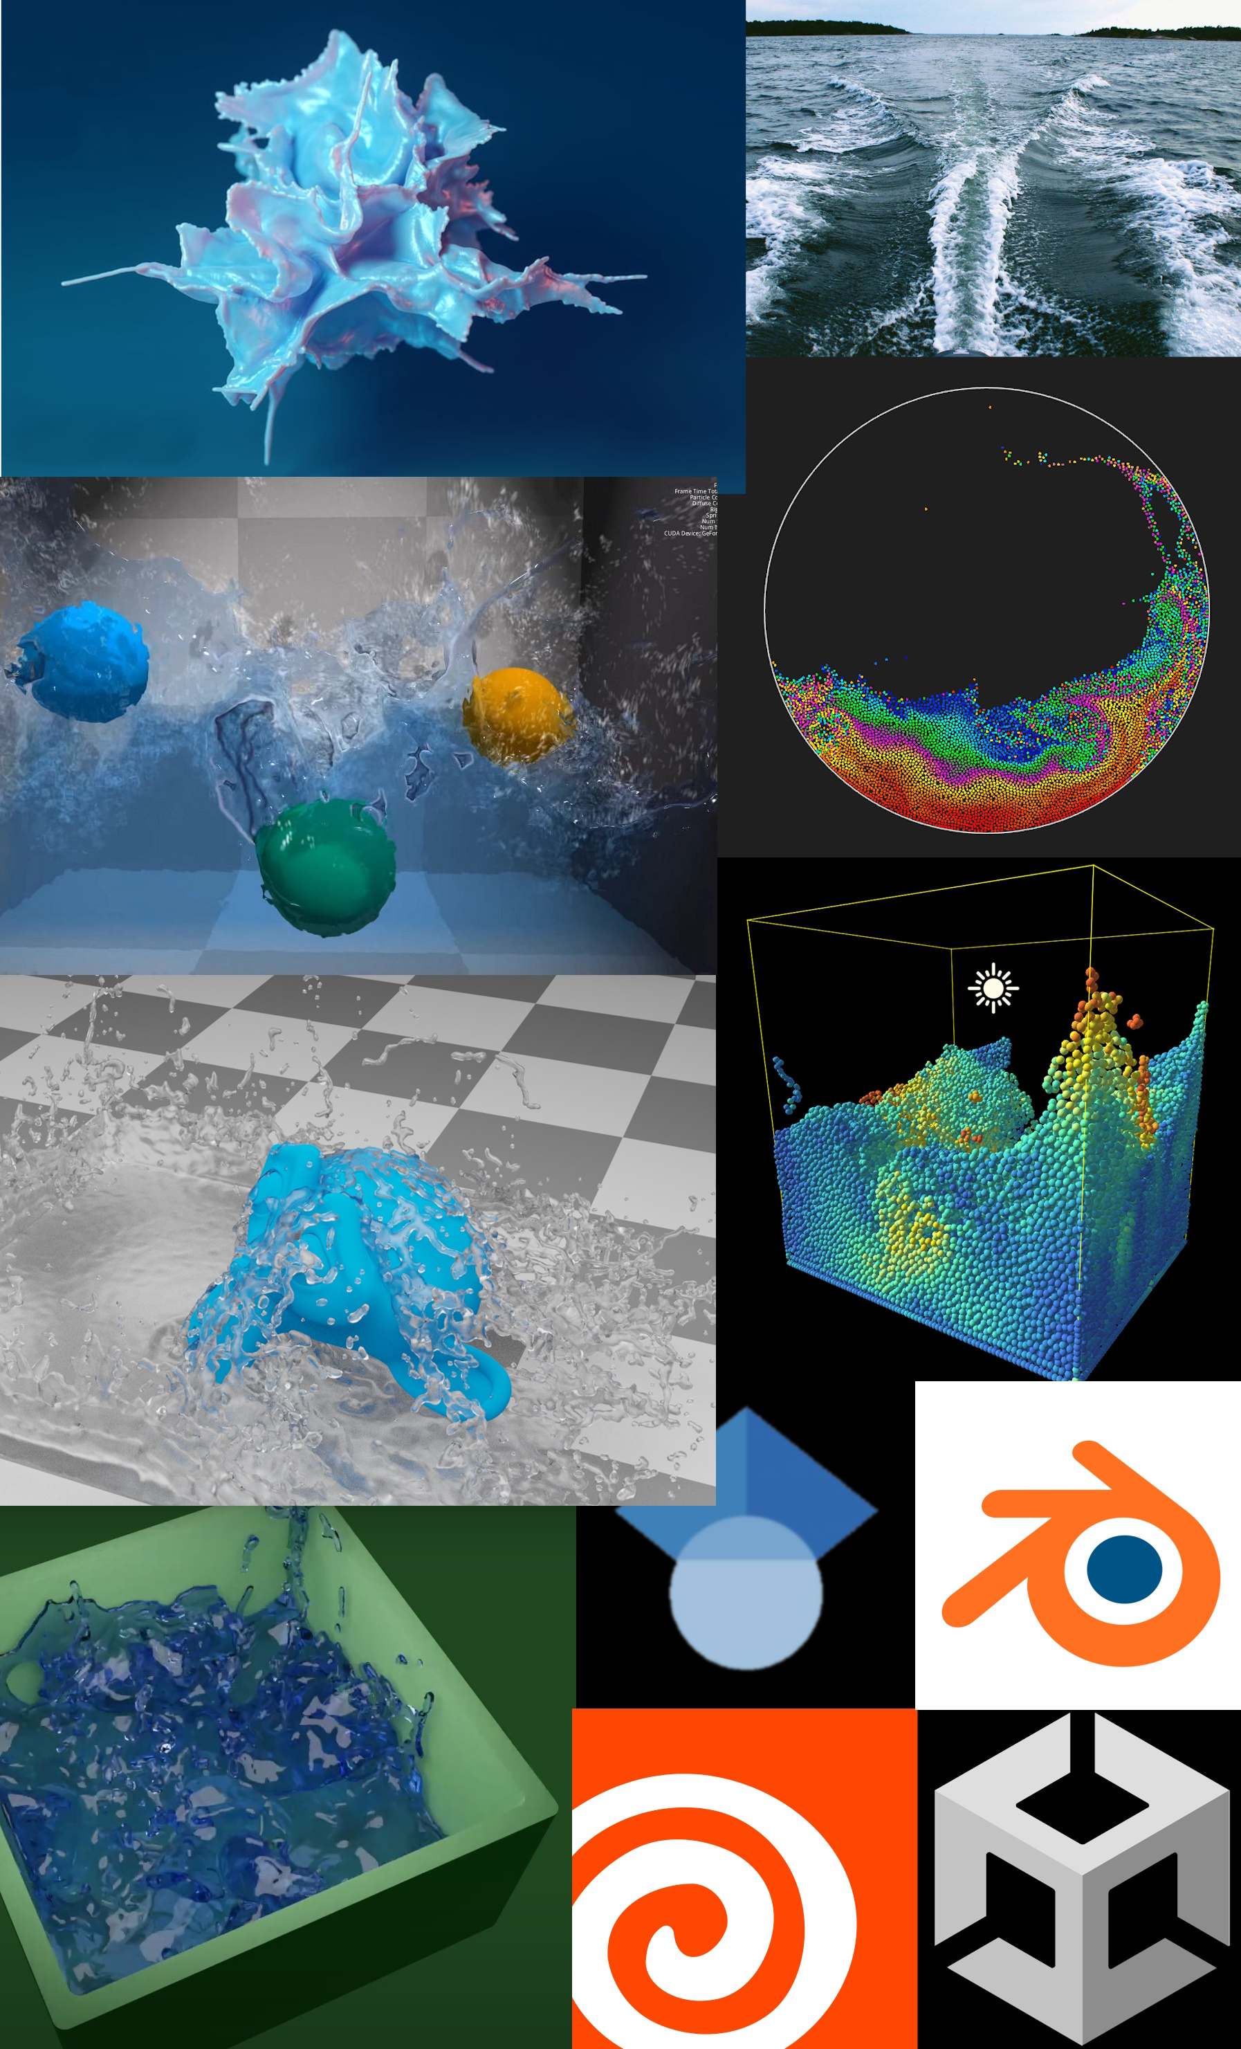
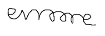
Signature: Date: 29/01/25

I have read and agree to abide by the ‘University’s ethical principles and guidelines for research’ as outlined in CT6007 UoG Ethics Guidelines. Submission of this form binds you to this requirement.

